***Virginia Junior Classical League***

*presents this*

Certificate of Excellence

*to*

Claire Jeantheau

*of*

Atlee High School

*for*

*1st Place in Mottoes, Quotes, and Abbreviations*

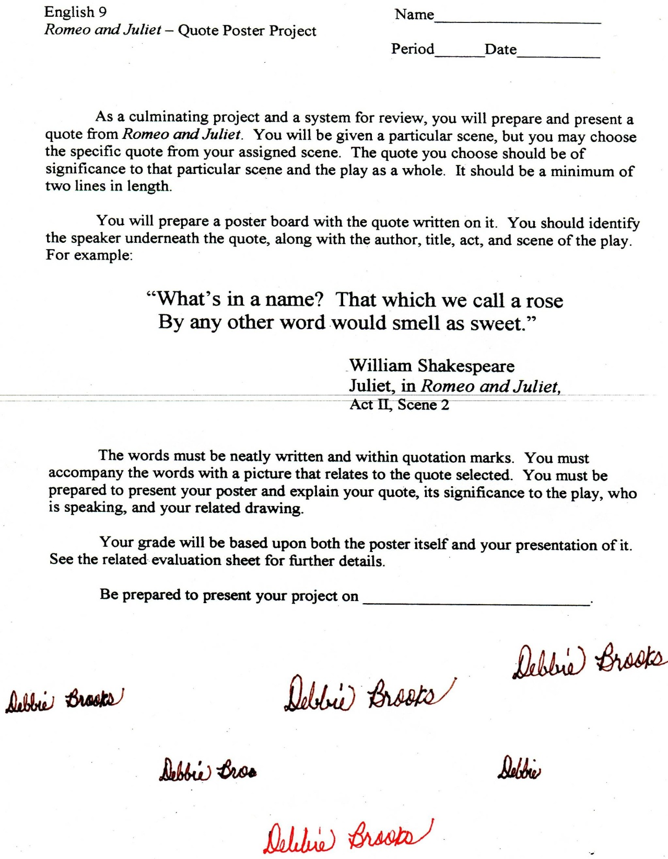

Microsoft Office Signature Line...

*a.d. viii Kal. Dec. MMDCCLXVII A.U.C. 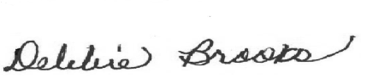*

***Virginia Junior Classical League***

*presents this*

Certificate of Excellence

*to*

Logan Shearon

*of*

Atlee High School

*for*

*3rd Place in Children's Book*

**

Microsoft Office Signature Line...

*a.d. viii Kal. Dec. MMDCCLXVII A.U.C. *

***Virginia Junior Classical League***

*presents this*

Certificate of Excellence

*to*

Grace Li

*of*

Atlee High School

*for*

*3rd Place in Jewelry*

**

Microsoft Office Signature Line...

*a.d. viii Kal. Dec. MMDCCLXVII A.U.C. *

***Virginia Junior Classical League***

*presents this*

Certificate of Excellence

*to*

Claire Jeantheau

*of*

Atlee High School

*for*

*3rd Place in Ornaments*

**

Microsoft Office Signature Line...

*a.d. viii Kal. Dec. MMDCCLXVII A.U.C. *

***Virginia Junior Classical League***

*presents this*

Certificate of Excellence

*to*

Claire Jeantheau

*of*

Atlee High School

*for*

*4th Place in Costume - Girls Upper Division*

**

Microsoft Office Signature Line...

*a.d. viii Kal. Dec. MMDCCLXVII A.U.C. *

***Virginia Junior Classical League***

*presents this*

Certificate of Excellence

*to*

Claire Jeantheau

*of*

Atlee High School

*for*

*5th Place in Cartoon*

**

Microsoft Office Signature Line...

*a.d. viii Kal. Dec. MMDCCLXVII A.U.C. *

***Virginia Junior Classical League***

*presents this*

Certificate of Excellence

*to*

Clair Martin

*of*

Atlee High School

*for*

*5th Place in Maps*

**

Microsoft Office Signature Line...

*a.d. viii Kal. Dec. MMDCCLXVII A.U.C. *

***Virginia Junior Classical League***

*presents this*

Certificate of Excellence

*to*

Justin Deuell

*of*

Atlee High School

*for*

*5th Place in Storytelling*

**

Microsoft Office Signature Line...

*a.d. viii Kal. Dec. MMDCCLXVII A.U.C. *

***Virginia Junior Classical League***

*presents this*

Certificate of Excellence

*to*

Axel Bax

*of*

Atlee High School

*for*

*7th Place in Mosaics*

**

Microsoft Office Signature Line...

*a.d. viii Kal. Dec. MMDCCLXVII A.U.C. *

***Virginia Junior Classical League***

*presents this*

Certificate of Excellence

*to*

Claire Jeantheau

*of*

Atlee High School

*for*

*7th Place in Reading Comprehension*

**

Microsoft Office Signature Line...

*a.d. viii Kal. Dec. MMDCCLXVII A.U.C. *

***Virginia Junior Classical League***

*presents this*

Certificate of Excellence

*to*

Grace Li

*of*

Atlee High School

*for*

*9th Place in Mythology*

**

Microsoft Office Signature Line...

*a.d. viii Kal. Dec. MMDCCLXVII A.U.C. *

***Virginia Junior Classical League***

*presents this*

Certificate of Excellence

*to*

Axel Bax

*of*

Atlee High School

*for*

*9th Place in Storytelling*

**

Microsoft Office Signature Line...

*a.d. viii Kal. Dec. MMDCCLXVII A.U.C. *