***Virginia Junior Classical League***

*presents this*

Certificate of Excellence

*to*

Matthew Mcbride

*of*

Courtland High School

*for*

*1st Place in Games*

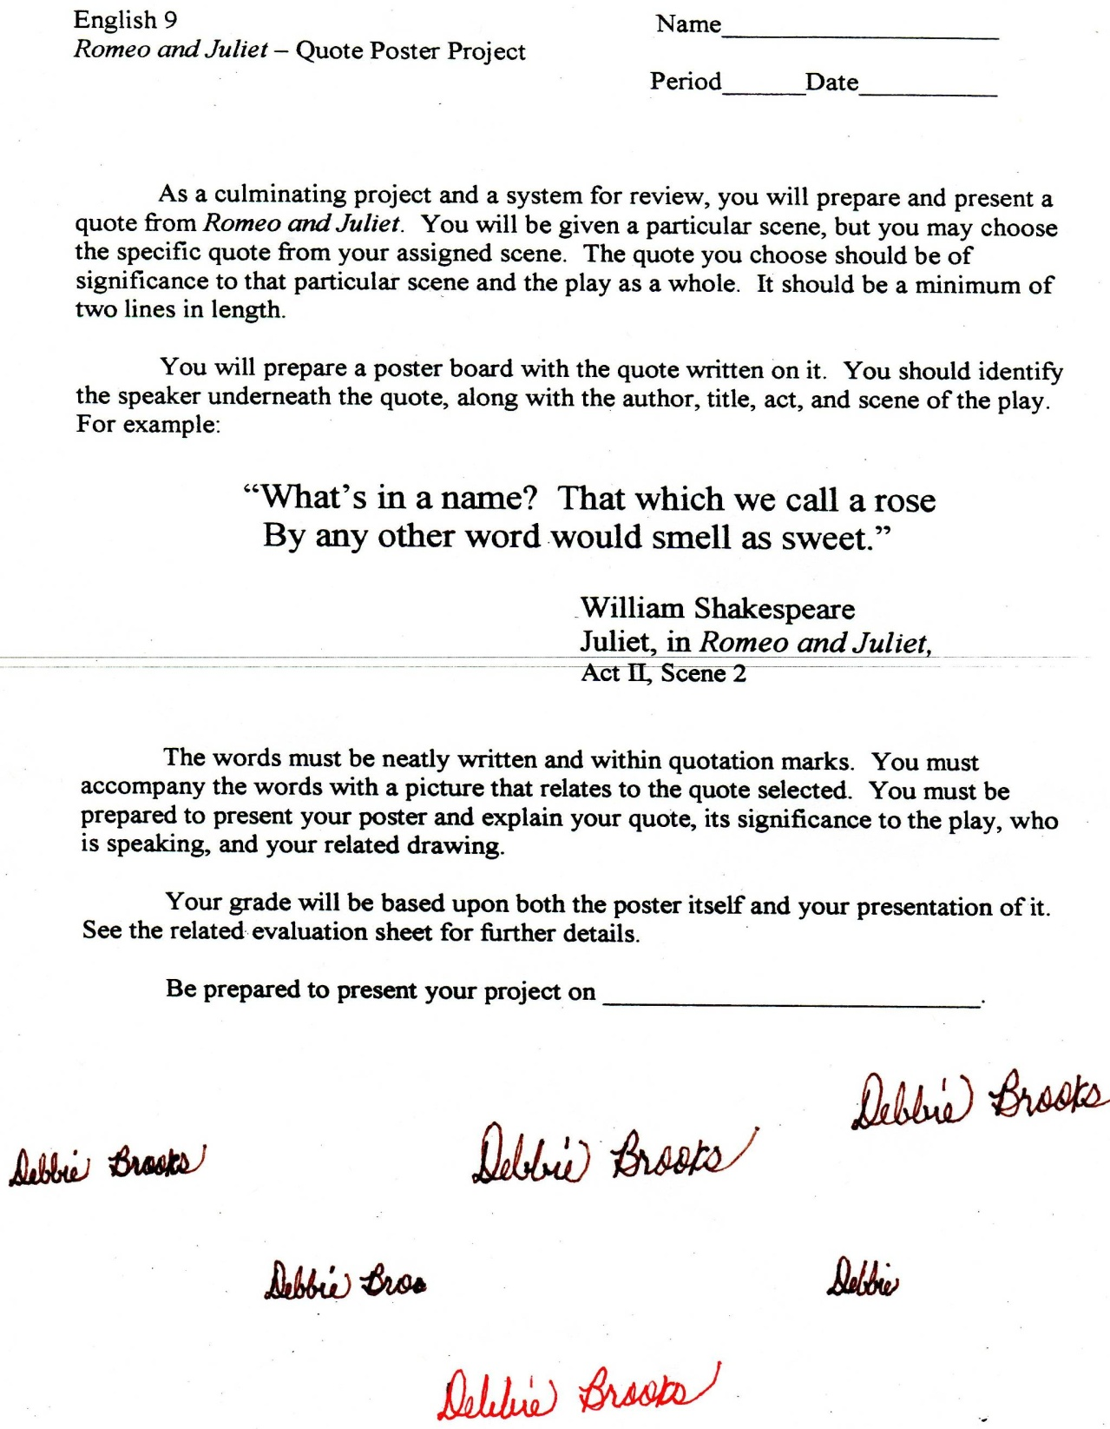

Microsoft Office Signature Line...

*a.d. viii Kal. Dec. MMDCCLXVII A.U.C. 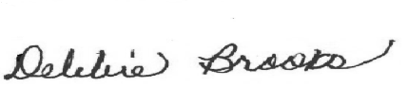*

***Virginia Junior Classical League***

*presents this*

Certificate of Excellence

*to*

Sydney Tune

*of*

Courtland High School

*for*

*1st Place in Impromptu Art*

**

Microsoft Office Signature Line...

*a.d. viii Kal. Dec. MMDCCLXVII A.U.C. *

***Virginia Junior Classical League***

*presents this*

Certificate of Excellence

*to*

Benjamin Tarnacki

*of*

Courtland High School

*for*

*1st Place in Sculpture*

**

Microsoft Office Signature Line...

*a.d. viii Kal. Dec. MMDCCLXVII A.U.C. *

***Virginia Junior Classical League***

*presents this*

Certificate of Excellence

*to*

Benjamin Tarnacki

*of*

Courtland High School

*for*

*2nd Place in Ornaments*

**

Microsoft Office Signature Line...

*a.d. viii Kal. Dec. MMDCCLXVII A.U.C. *

***Virginia Junior Classical League***

*presents this*

Certificate of Excellence

*to*

Kevin Guditus

*of*

Courtland High School

*for*

*3rd Place in Large Model*

**

Microsoft Office Signature Line...

*a.d. viii Kal. Dec. MMDCCLXVII A.U.C. *

***Virginia Junior Classical League***

*presents this*

Certificate of Excellence

*to*

Amber Horton

*of*

Courtland High School

*for*

*4th Place in Dolls*

**

Microsoft Office Signature Line...

*a.d. viii Kal. Dec. MMDCCLXVII A.U.C. *

***Virginia Junior Classical League***

*presents this*

Certificate of Excellence

*to*

Molly Mansfield

*of*

Courtland High School

*for*

*4th Place in Jewelry*

**

Microsoft Office Signature Line...

*a.d. viii Kal. Dec. MMDCCLXVII A.U.C. *

***Virginia Junior Classical League***

*presents this*

Certificate of Excellence

*to*

Chelsea Malaeb

*of*

Courtland High School

*for*

*5th Place in History*

**

Microsoft Office Signature Line...

*a.d. viii Kal. Dec. MMDCCLXVII A.U.C. *

***Virginia Junior Classical League***

*presents this*

Certificate of Excellence

*to*

Caroline Hieber

*of*

Courtland High School

*for*

*6th Place in Cartoon*

**

Microsoft Office Signature Line...

*a.d. viii Kal. Dec. MMDCCLXVII A.U.C. *

***Virginia Junior Classical League***

*presents this*

Certificate of Excellence

*to*

Chelsea Malaeb

*of*

Courtland High School

*for*

*6th Place in Cartoon*

**

Microsoft Office Signature Line...

*a.d. viii Kal. Dec. MMDCCLXVII A.U.C. *

***Virginia Junior Classical League***

*presents this*

Certificate of Excellence

*to*

Amber Horton

*of*

Courtland High School

*for*

*6th Place in Life*

**

Microsoft Office Signature Line...

*a.d. viii Kal. Dec. MMDCCLXVII A.U.C. *

***Virginia Junior Classical League***

*presents this*

Certificate of Excellence

*to*

Molly Mansfield

*of*

Courtland High School

*for*

*7th Place in Costume - Girls Upper Division*

**

Microsoft Office Signature Line...

*a.d. viii Kal. Dec. MMDCCLXVII A.U.C. *

***Virginia Junior Classical League***

*presents this*

Certificate of Excellence

*to*

Kevin Guditus

*of*

Courtland High School

*for*

*7th Place in Small Models*

**

Microsoft Office Signature Line...

*a.d. viii Kal. Dec. MMDCCLXVII A.U.C. *

***Virginia Junior Classical League***

*presents this*

Certificate of Excellence

*to*

Sydney Tune

*of*

Courtland High School

*for*

*10th Place in Life*

**

Microsoft Office Signature Line...

*a.d. viii Kal. Dec. MMDCCLXVII A.U.C. *

***Virginia Junior Classical League***

*presents this*

Certificate of Excellence

*to*

Chelsea Malaeb

*of*

Courtland High School

*for*

*10th Place in Life*

**

Microsoft Office Signature Line...

*a.d. viii Kal. Dec. MMDCCLXVII A.U.C. *