***Virginia Junior Classical League***

*presents this*

Certificate of Excellence

*to*

Matthew Neri

*of*

Gunston Middle School

*for*

*3rd Place in Derivatives*

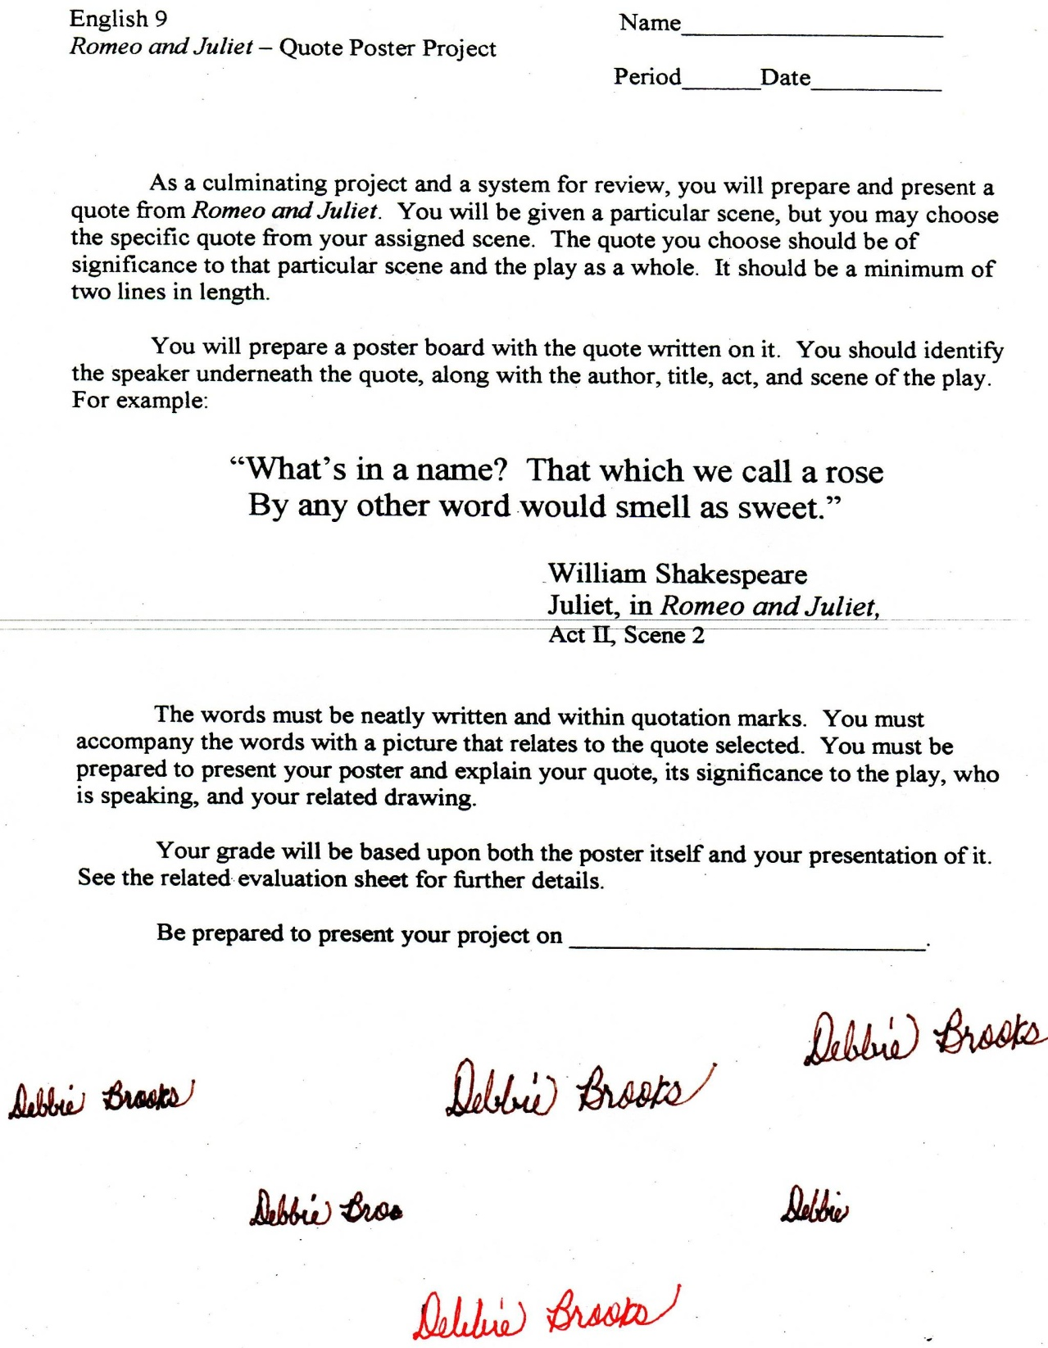

Microsoft Office Signature Line...

*a.d. viii Kal. Dec. MMDCCLXVII A.U.C. 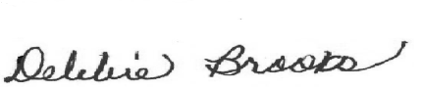*

***Virginia Junior Classical League***

*presents this*

Certificate of Excellence

*to*

Samantha Brem

*of*

Gunston Middle School

*for*

*4th Place in Oil*

**

Microsoft Office Signature Line...

*a.d. viii Kal. Dec. MMDCCLXVII A.U.C. *

***Virginia Junior Classical League***

*presents this*

Certificate of Excellence

*to*

Samantha Brem

*of*

Gunston Middle School

*for*

*5th Place in Mythology*

**

Microsoft Office Signature Line...

*a.d. viii Kal. Dec. MMDCCLXVII A.U.C. *

***Virginia Junior Classical League***

*presents this*

Certificate of Excellence

*to*

Matthew Neri

*of*

Gunston Middle School

*for*

*7th Place in Reading Comprehension*

**

Microsoft Office Signature Line...

*a.d. viii Kal. Dec. MMDCCLXVII A.U.C. *

***Virginia Junior Classical League***

*presents this*

Certificate of Excellence

*to*

Samantha Brem

*of*

Gunston Middle School

*for*

*8th Place in Life*

**

Microsoft Office Signature Line...

*a.d. viii Kal. Dec. MMDCCLXVII A.U.C. *