***Virginia Junior Classical League***

*presents this*

Certificate of Excellence

*to*

Sabrina Zafar

*of*

Herndon High School

*for*

*1st Place in Children's Book*

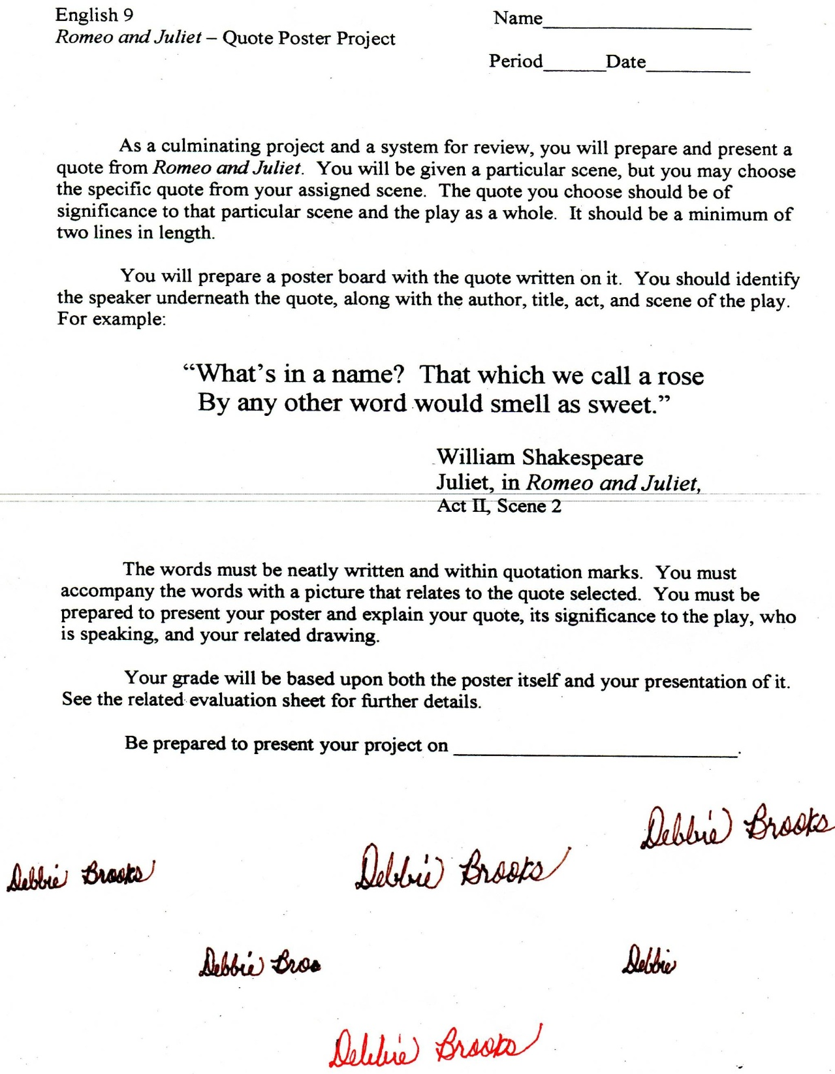

Microsoft Office Signature Line...

*a.d. viii Kal. Dec. MMDCCLXVII A.U.C. 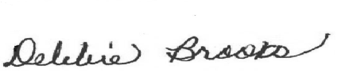*

***Virginia Junior Classical League***

*presents this*

Certificate of Excellence

*to*

Nicolo Allado

*of*

Herndon High School

*for*

*1st Place in History*

**

Microsoft Office Signature Line...

*a.d. viii Kal. Dec. MMDCCLXVII A.U.C. *

***Virginia Junior Classical League***

*presents this*

Certificate of Excellence

*to*

Mary Ogborn

*of*

Herndon High School

*for*

*1st Place in Jewelry*

**

Microsoft Office Signature Line...

*a.d. viii Kal. Dec. MMDCCLXVII A.U.C. *

***Virginia Junior Classical League***

*presents this*

Certificate of Excellence

*to*

Dora Drezga

*of*

Herndon High School

*for*

*2nd Place in History*

**

Microsoft Office Signature Line...

*a.d. viii Kal. Dec. MMDCCLXVII A.U.C. *

***Virginia Junior Classical League***

*presents this*

Certificate of Excellence

*to*

Nicolo Allado

*of*

Herndon High School

*for*

*2nd Place in Mythology*

**

Microsoft Office Signature Line...

*a.d. viii Kal. Dec. MMDCCLXVII A.U.C. *

***Virginia Junior Classical League***

*presents this*

Certificate of Excellence

*to*

Dora Drezga

*of*

Herndon High School

*for*

*3rd Place in Mythology*

**

Microsoft Office Signature Line...

*a.d. viii Kal. Dec. MMDCCLXVII A.U.C. *

***Virginia Junior Classical League***

*presents this*

Certificate of Excellence

*to*

Elise Smagh

*of*

Herndon High School

*for*

*4th Place in Charcoal*

**

Microsoft Office Signature Line...

*a.d. viii Kal. Dec. MMDCCLXVII A.U.C. *

***Virginia Junior Classical League***

*presents this*

Certificate of Excellence

*to*

Dora Drezga

*of*

Herndon High School

*for*

*7th Place in Geography*

**

Microsoft Office Signature Line...

*a.d. viii Kal. Dec. MMDCCLXVII A.U.C. *

***Virginia Junior Classical League***

*presents this*

Certificate of Excellence

*to*

Elise Smagh

*of*

Herndon High School

*for*

*7th Place in Mythology*

**

Microsoft Office Signature Line...

*a.d. viii Kal. Dec. MMDCCLXVII A.U.C. *

***Virginia Junior Classical League***

*presents this*

Certificate of Excellence

*to*

Shruti Shrivastava

*of*

Herndon High School

*for*

*8th Place in Other*

**

Microsoft Office Signature Line...

*a.d. viii Kal. Dec. MMDCCLXVII A.U.C. *