***Virginia Junior Classical League***

*presents this*

Certificate of Excellence

*to*

Jordan McLeod

*of*

Lois S. Hornsby Middle School

*for*

*1st Place in Modern Myth*

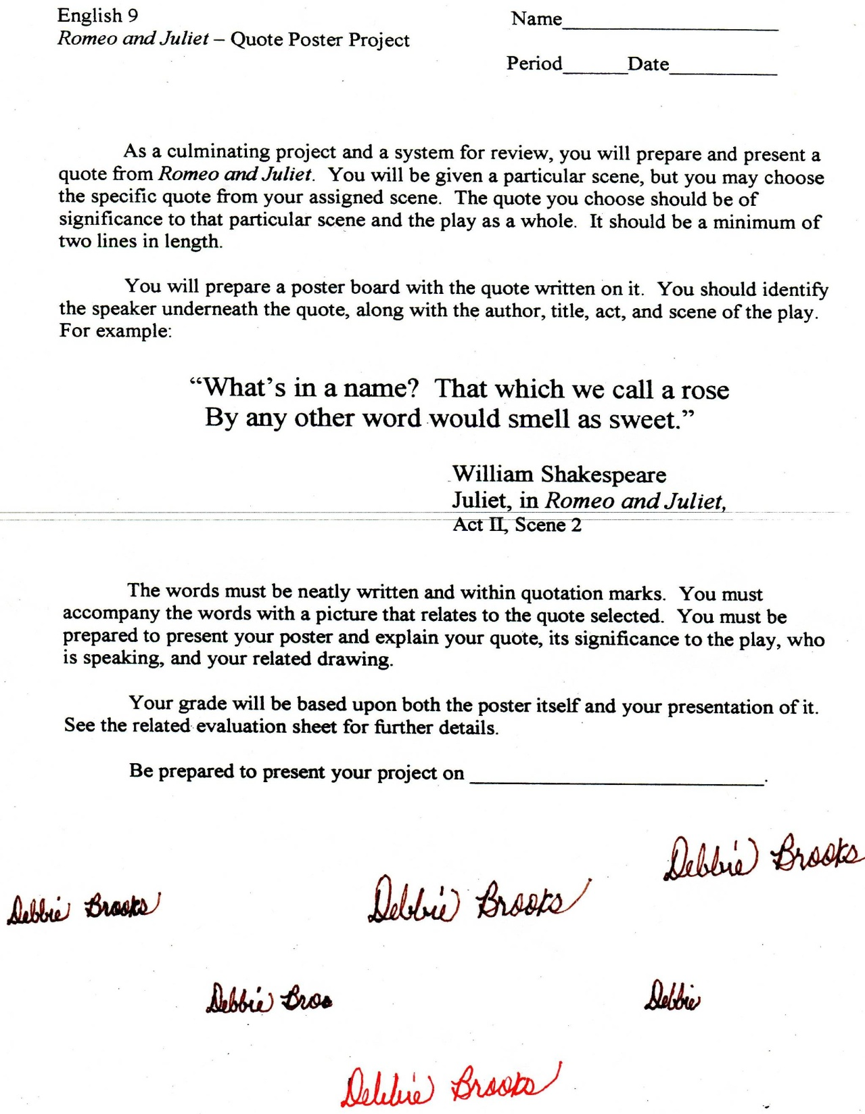

Microsoft Office Signature Line...

*a.d. viii Kal. Dec. MMDCCLXVII A.U.C. 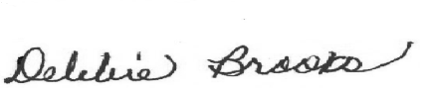*

***Virginia Junior Classical League***

*presents this*

Certificate of Excellence

*to*

Jordan McLeod

*of*

Lois S. Hornsby Middle School

*for*

*2nd Place in Costume - Boys Lower Division*

**

Microsoft Office Signature Line...

*a.d. viii Kal. Dec. MMDCCLXVII A.U.C. *

***Virginia Junior Classical League***

*presents this*

Certificate of Excellence

*to*

Annabelle Kelley

*of*

Lois S. Hornsby Middle School

*for*

*2nd Place in Modern Myth*

**

Microsoft Office Signature Line...

*a.d. viii Kal. Dec. MMDCCLXVII A.U.C. *

***Virginia Junior Classical League***

*presents this*

Certificate of Excellence

*to*

Gracie Dry

*of*

Lois S. Hornsby Middle School

*for*

*3rd Place in Storytelling*

**

Microsoft Office Signature Line...

*a.d. viii Kal. Dec. MMDCCLXVII A.U.C. *

***Virginia Junior Classical League***

*presents this*

Certificate of Excellence

*to*

Annabelle Kelley

*of*

Lois S. Hornsby Middle School

*for*

*4th Place in Costume - Girls Lower Division*

**

Microsoft Office Signature Line...

*a.d. viii Kal. Dec. MMDCCLXVII A.U.C. *

***Virginia Junior Classical League***

*presents this*

Certificate of Excellence

*to*

Annabelle Kelley

*of*

Lois S. Hornsby Middle School

*for*

*5th Place in Greeting Card*

**

Microsoft Office Signature Line...

*a.d. viii Kal. Dec. MMDCCLXVII A.U.C. *

***Virginia Junior Classical League***

*presents this*

Certificate of Excellence

*to*

Annabelle Kelley

*of*

Lois S. Hornsby Middle School

*for*

*6th Place in Dolls*

**

Microsoft Office Signature Line...

*a.d. viii Kal. Dec. MMDCCLXVII A.U.C. *

***Virginia Junior Classical League***

*presents this*

Certificate of Excellence

*to*

Annabelle Kelley

*of*

Lois S. Hornsby Middle School

*for*

*6th Place in Storytelling*

**

Microsoft Office Signature Line...

*a.d. viii Kal. Dec. MMDCCLXVII A.U.C. *

***Virginia Junior Classical League***

*presents this*

Certificate of Excellence

*to*

Gracie Dry

*of*

Lois S. Hornsby Middle School

*for*

*7th Place in Mosaics*

**

Microsoft Office Signature Line...

*a.d. viii Kal. Dec. MMDCCLXVII A.U.C. *

***Virginia Junior Classical League***

*presents this*

Certificate of Excellence

*to*

Gracie Dry

*of*

Lois S. Hornsby Middle School

*for*

*9th Place in Modern Myth*

**

Microsoft Office Signature Line...

*a.d. viii Kal. Dec. MMDCCLXVII A.U.C. *

***Virginia Junior Classical League***

*presents this*

Certificate of Excellence

*to*

Jordan McLeod

*of*

Lois S. Hornsby Middle School

*for*

*9th Place in Pencil*

**

Microsoft Office Signature Line...

*a.d. viii Kal. Dec. MMDCCLXVII A.U.C. *