***Virginia Junior Classical League***

*presents this*

Certificate of Excellence

*to*

Wright Keanna

*of*

Kecoughtan

*for*

*1st Place in Other*

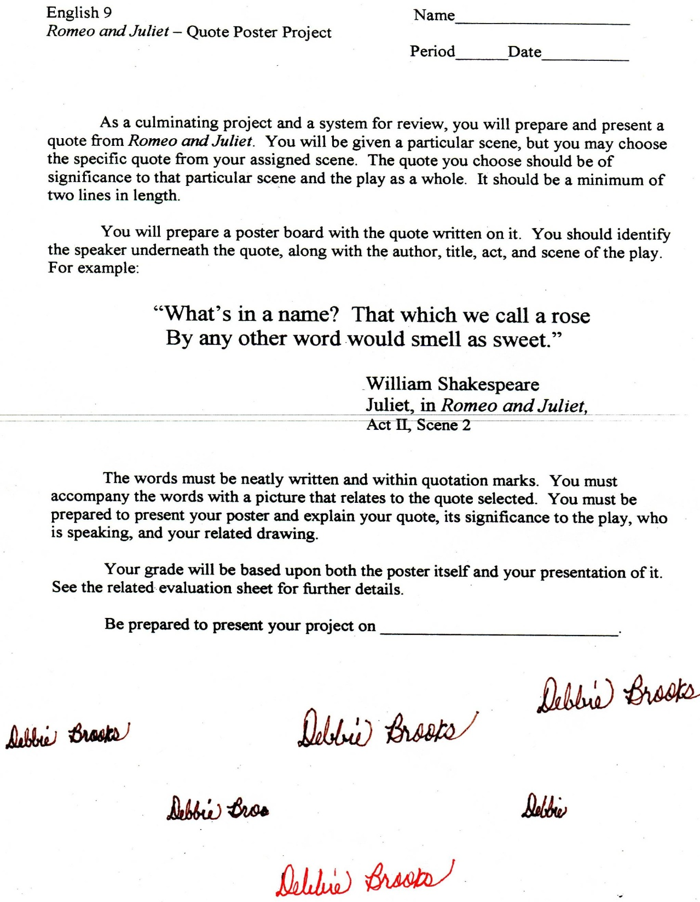

Microsoft Office Signature Line...

*a.d. viii Kal. Dec. MMDCCLXVII A.U.C. 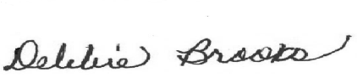*

***Virginia Junior Classical League***

*presents this*

Certificate of Excellence

*to*

Justice Wade

*of*

Kecoughtan

*for*

*6th Place in English Oratory*

**

Microsoft Office Signature Line...

*a.d. viii Kal. Dec. MMDCCLXVII A.U.C. *

***Virginia Junior Classical League***

*presents this*

Certificate of Excellence

*to*

Riddick Dai'Ja

*of*

Kecoughtan

*for*

*6th Place in Oil*

**

Microsoft Office Signature Line...

*a.d. viii Kal. Dec. MMDCCLXVII A.U.C. *

***Virginia Junior Classical League***

*presents this*

Certificate of Excellence

*to*

Brown Curtis

*of*

Kecoughtan

*for*

*7th Place in Games*

**

Microsoft Office Signature Line...

*a.d. viii Kal. Dec. MMDCCLXVII A.U.C. *

***Virginia Junior Classical League***

*presents this*

Certificate of Excellence

*to*

William Olson

*of*

Kecoughtan

*for*

*7th Place in Mottoes, Quotes, and Abbreviations*

**

Microsoft Office Signature Line...

*a.d. viii Kal. Dec. MMDCCLXVII A.U.C. *

***Virginia Junior Classical League***

*presents this*

Certificate of Excellence

*to*

Molly Ruth

*of*

Kecoughtan

*for*

*8th Place in Children's Book*

**

Microsoft Office Signature Line...

*a.d. viii Kal. Dec. MMDCCLXVII A.U.C. *

***Virginia Junior Classical League***

*presents this*

Certificate of Excellence

*to*

William Olson

*of*

Kecoughtan

*for*

*8th Place in Children's Book*

**

Microsoft Office Signature Line...

*a.d. viii Kal. Dec. MMDCCLXVII A.U.C. *

***Virginia Junior Classical League***

*presents this*

Certificate of Excellence

*to*

Jaliah Johnson

*of*

Kecoughtan

*for*

*8th Place in Oil*

**

Microsoft Office Signature Line...

*a.d. viii Kal. Dec. MMDCCLXVII A.U.C. *

***Virginia Junior Classical League***

*presents this*

Certificate of Excellence

*to*

Kay Barber

*of*

Kecoughtan

*for*

*9th Place in Children's Book*

**

Microsoft Office Signature Line...

*a.d. viii Kal. Dec. MMDCCLXVII A.U.C. *

***Virginia Junior Classical League***

*presents this*

Certificate of Excellence

*to*

Kay Barber

*of*

Kecoughtan

*for*

*9th Place in Mottoes, Quotes, and Abbreviations*

**

Microsoft Office Signature Line...

*a.d. viii Kal. Dec. MMDCCLXVII A.U.C. *