***Virginia Junior Classical League***

*presents this*

Certificate of Excellence

*to*

Hailey Botkins

*of*

Lafayette High School

*for*

*1st Place in Modern Myth*

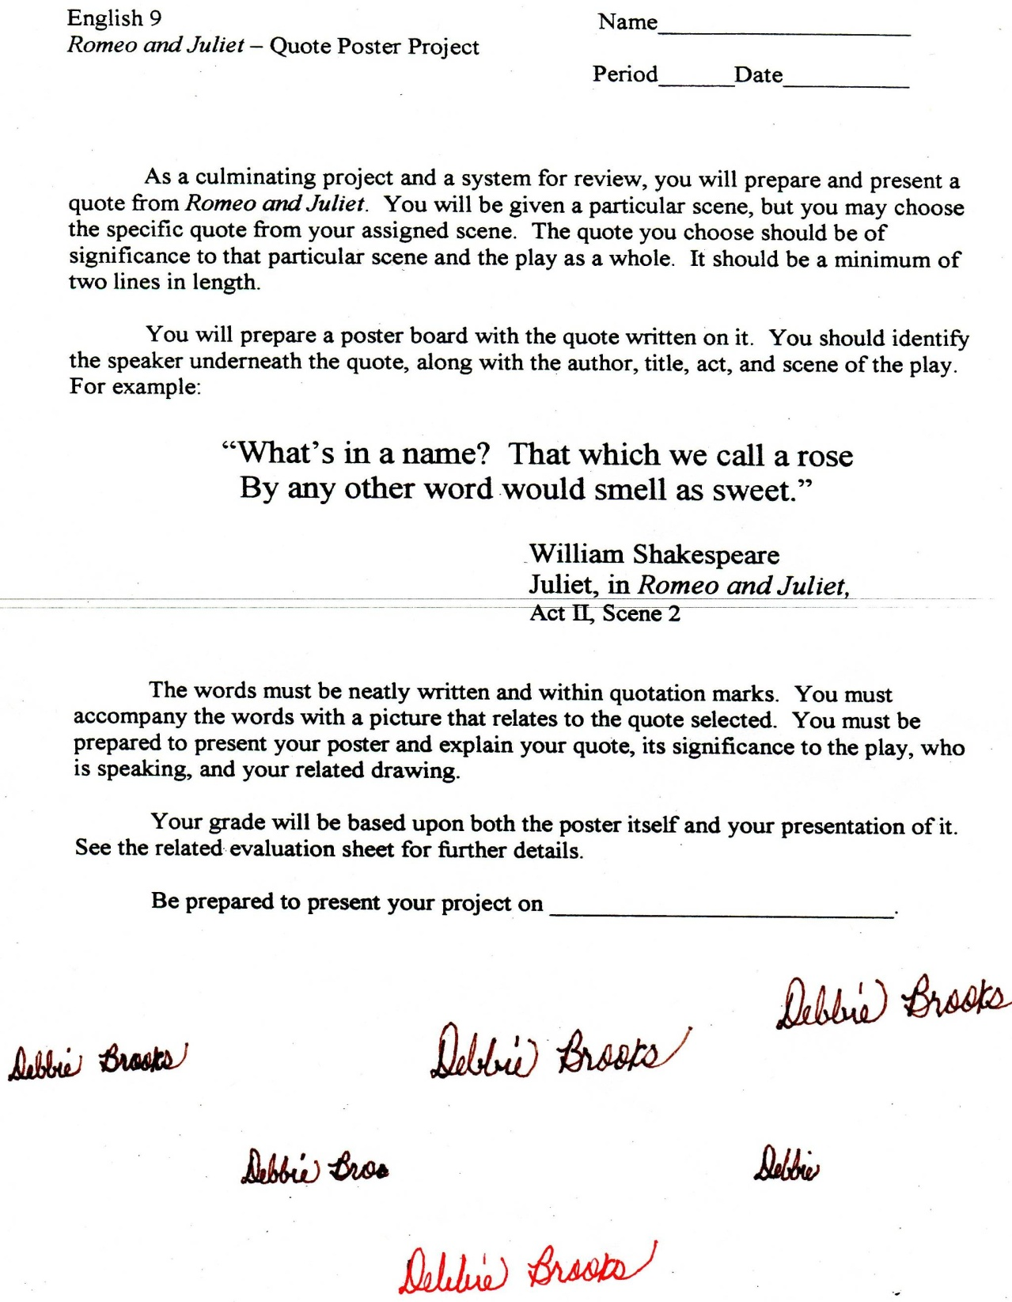

Microsoft Office Signature Line...

*a.d. viii Kal. Dec. MMDCCLXVII A.U.C. 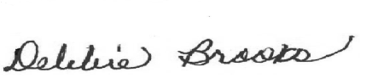*

***Virginia Junior Classical League***

*presents this*

Certificate of Excellence

*to*

Elim Utterback

*of*

Lafayette High School

*for*

*2nd Place in Modern Myth*

**

Microsoft Office Signature Line...

*a.d. viii Kal. Dec. MMDCCLXVII A.U.C. *

***Virginia Junior Classical League***

*presents this*

Certificate of Excellence

*to*

Benjamin Petrakis

*of*

Lafayette High School

*for*

*4th Place in Modern Myth*

**

Microsoft Office Signature Line...

*a.d. viii Kal. Dec. MMDCCLXVII A.U.C. *

***Virginia Junior Classical League***

*presents this*

Certificate of Excellence

*to*

Benjamin Petrakis

*of*

Lafayette High School

*for*

*6th Place in Children's Book*

**

Microsoft Office Signature Line...

*a.d. viii Kal. Dec. MMDCCLXVII A.U.C. *

***Virginia Junior Classical League***

*presents this*

Certificate of Excellence

*to*

Hailey Botkins

*of*

Lafayette High School

*for*

*6th Place in History*

**

Microsoft Office Signature Line...

*a.d. viii Kal. Dec. MMDCCLXVII A.U.C. *

***Virginia Junior Classical League***

*presents this*

Certificate of Excellence

*to*

John Patterson

*of*

Lafayette High School

*for*

*6th Place in Modern Myth*

**

Microsoft Office Signature Line...

*a.d. viii Kal. Dec. MMDCCLXVII A.U.C. *

***Virginia Junior Classical League***

*presents this*

Certificate of Excellence

*to*

John Patterson

*of*

Lafayette High School

*for*

*7th Place in Dramatic Interpretation*

**

Microsoft Office Signature Line...

*a.d. viii Kal. Dec. MMDCCLXVII A.U.C. *

***Virginia Junior Classical League***

*presents this*

Certificate of Excellence

*to*

Hailey Botkins

*of*

Lafayette High School

*for*

*7th Place in Dramatic Interpretation*

**

Microsoft Office Signature Line...

*a.d. viii Kal. Dec. MMDCCLXVII A.U.C. *

***Virginia Junior Classical League***

*presents this*

Certificate of Excellence

*to*

John Patterson

*of*

Lafayette High School

*for*

*7th Place in History*

**

Microsoft Office Signature Line...

*a.d. viii Kal. Dec. MMDCCLXVII A.U.C. *

***Virginia Junior Classical League***

*presents this*

Certificate of Excellence

*to*

John Patterson

*of*

Lafayette High School

*for*

*8th Place in Vocabulary*

**

Microsoft Office Signature Line...

*a.d. viii Kal. Dec. MMDCCLXVII A.U.C. *

***Virginia Junior Classical League***

*presents this*

Certificate of Excellence

*to*

Benjamin Petrakis

*of*

Lafayette High School

*for*

*9th Place in Pencil*

**

Microsoft Office Signature Line...

*a.d. viii Kal. Dec. MMDCCLXVII A.U.C. *

***Virginia Junior Classical League***

*presents this*

Certificate of Excellence

*to*

Hailey Botkins

*of*

Lafayette High School

*for*

*9th Place in Storytelling*

**

Microsoft Office Signature Line...

*a.d. viii Kal. Dec. MMDCCLXVII A.U.C. *