***Virginia Junior Classical League***

*presents this*

Certificate of Excellence

*to*

Colin Little

*of*

Loudoun County High School

*for*

*10th Place in Derivatives*

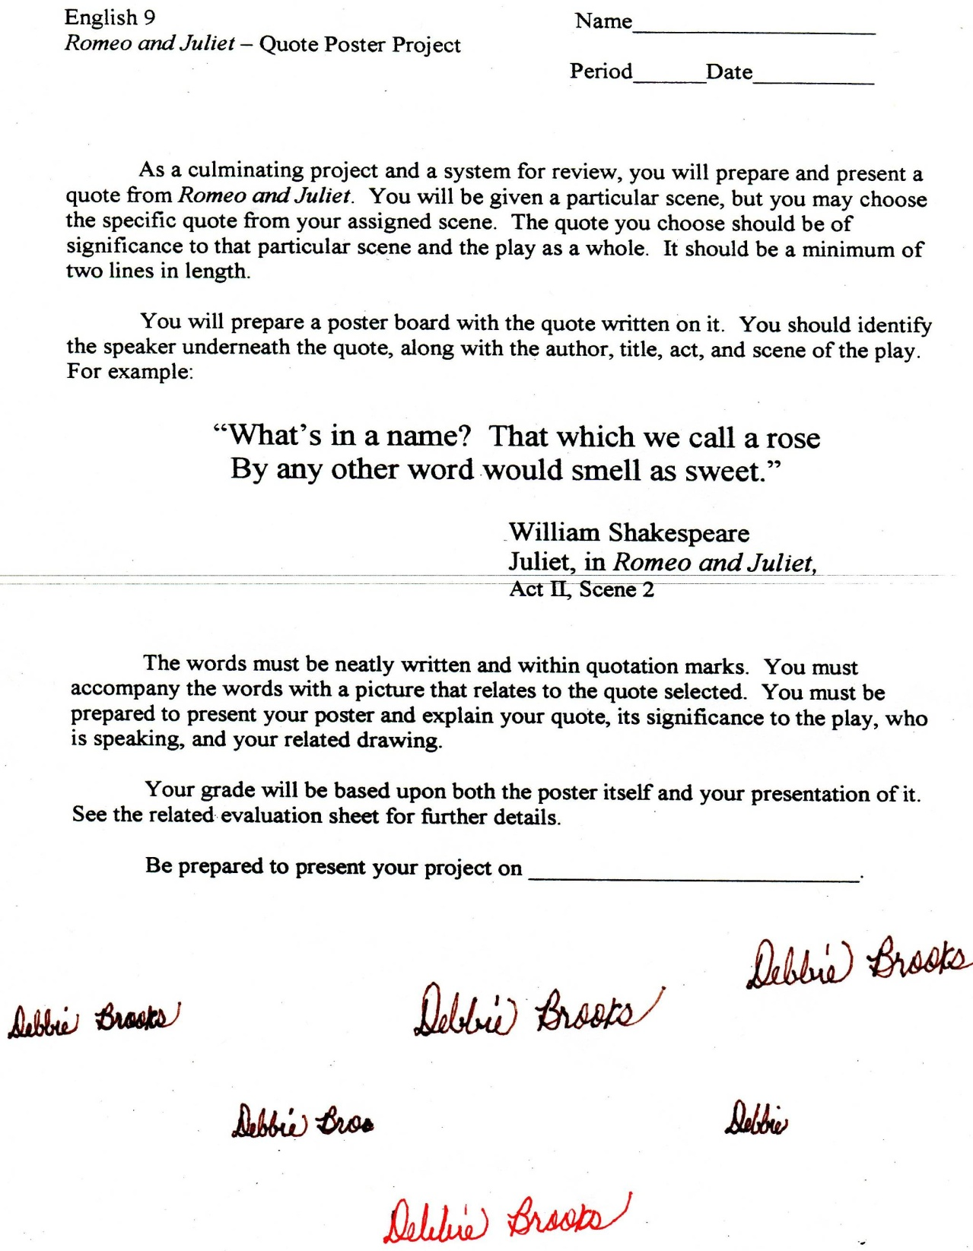

Microsoft Office Signature Line...

*a.d. viii Kal. Dec. MMDCCLXVII A.U.C. 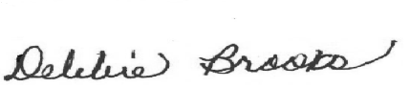*

***Virginia Junior Classical League***

*presents this*

Certificate of Excellence

*to*

Megan McKay

*of*

Loudoun County High School

*for*

*10th Place in Reading Comprehension*

**

Microsoft Office Signature Line...

*a.d. viii Kal. Dec. MMDCCLXVII A.U.C. *